**Lt. Col. (ret.) Jennifer Avery, No. 1, Spirit Number 278**

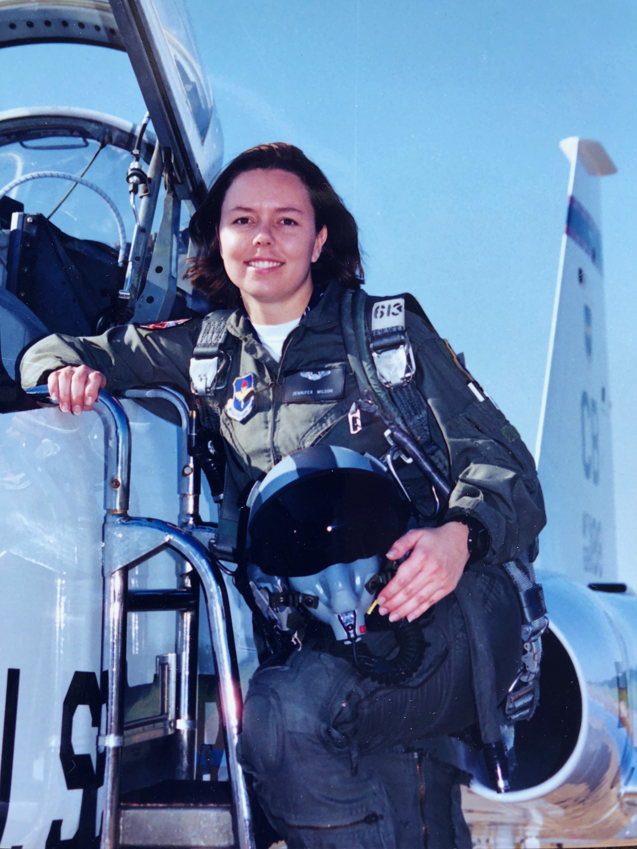

**By Brye Steeves**

**509th Bomb Wing Public Affairs**

Jennifer Avery made history on Feb. 12, 2002.

She was so excited – and nervous – that when she was collecting her parachute, helmet and other gear, she grabbed two right-handed gloves. Avery didn’t realize this until she was in the cockpit and it was time to taxi. So, she wore one glove backwards and hoped the instructor pilot sitting shoulder-to-shoulder with her didn’t notice. He did.

But it in no way hindered Avery’s flight, which she completed successfully, becoming the first female pilot to fly the B-2 stealth bomber.

“It’s still surprising to hear. Shocking, actually. I feel shocked that it’s me because I’m just me.”

Before her flight that day, the B-2’s two-person cockpit had to be modified with privacy curtains around the small toilet, which is necessary because the B-2 is capable of long-duration sorties with its lengthiest ever clocking in at 44 consecutive hours.

“To be able to fly such a unique aircraft that is the backbone of our nation’s nuclear-deterrence defense was a dream come true,” Avery said.

Her fascination with aviation started when she was just a child and her Uncle Bill took her into an aircraft simulator at Charleston Air Force Base, South Carolina, and continued during her college years at Georgia Institute of Technology, where she loved hearing the sound of F-15 fighter jets buzz over her apartment.

After graduating and commissioning as a second lieutenant in the Air Force, Avery earned her wings and was sent to Ellsworth AFB, South Dakota, to fly the B-1 Lancer. She was the first female pilot to fly the B-1 in combat.

Not long after becoming a B-2 pilot, she was the first – and still only – female to pilot the stealth bomber in combat, in support of Operation Iraqi Freedom in 2003.

“I’m proud of myself,” Avery said, but at the same time she didn’t want her gender to be a factor in her achievements.

“I didn’t want to use it to my advantage, ever,” she said. “I didn’t want that to be a reason that I succeeded. I never wanted anyone to think I had gotten to where I was because of being a woman.”